Task Description #1:
• Introduce a buggy Python function that calculates the factorial of a number using recursion. Use Copilot or Cursor AI to detect and fix the logical or syntax errors.
Expected Outcome #1:
•Copilot or Cursor AI correctly identifies missing base condition or incorrect recursive call and suggests a functional factorial implementation.

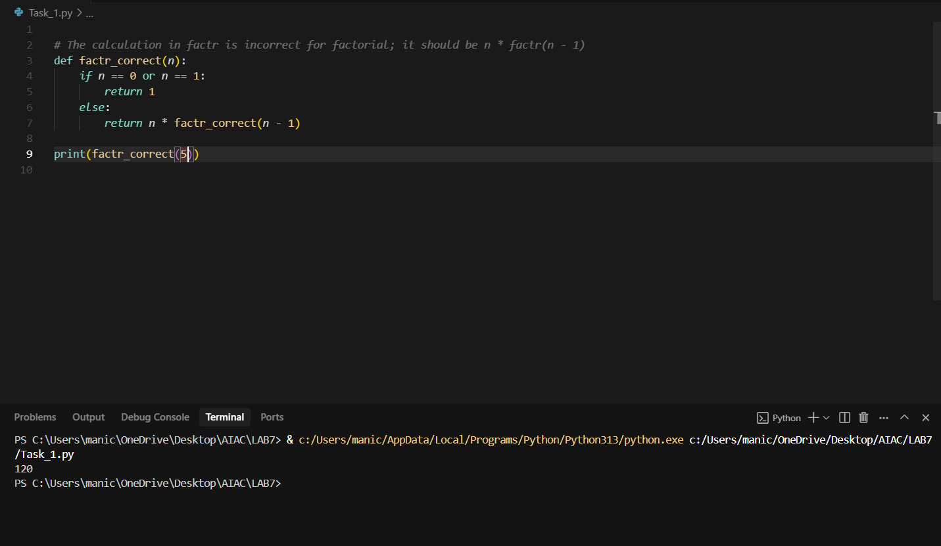

Task Description #2:
•Provide a list sorting function that fails due to a type error (e.g., sorting list with mixed integers and strings). Prompt AI to detect the issue and fix the code for consistent sorting.
Expected Outcome #2:
•AI detects the type inconsistency and either filters or converts list elements, ensuring successful sorting without a crash.
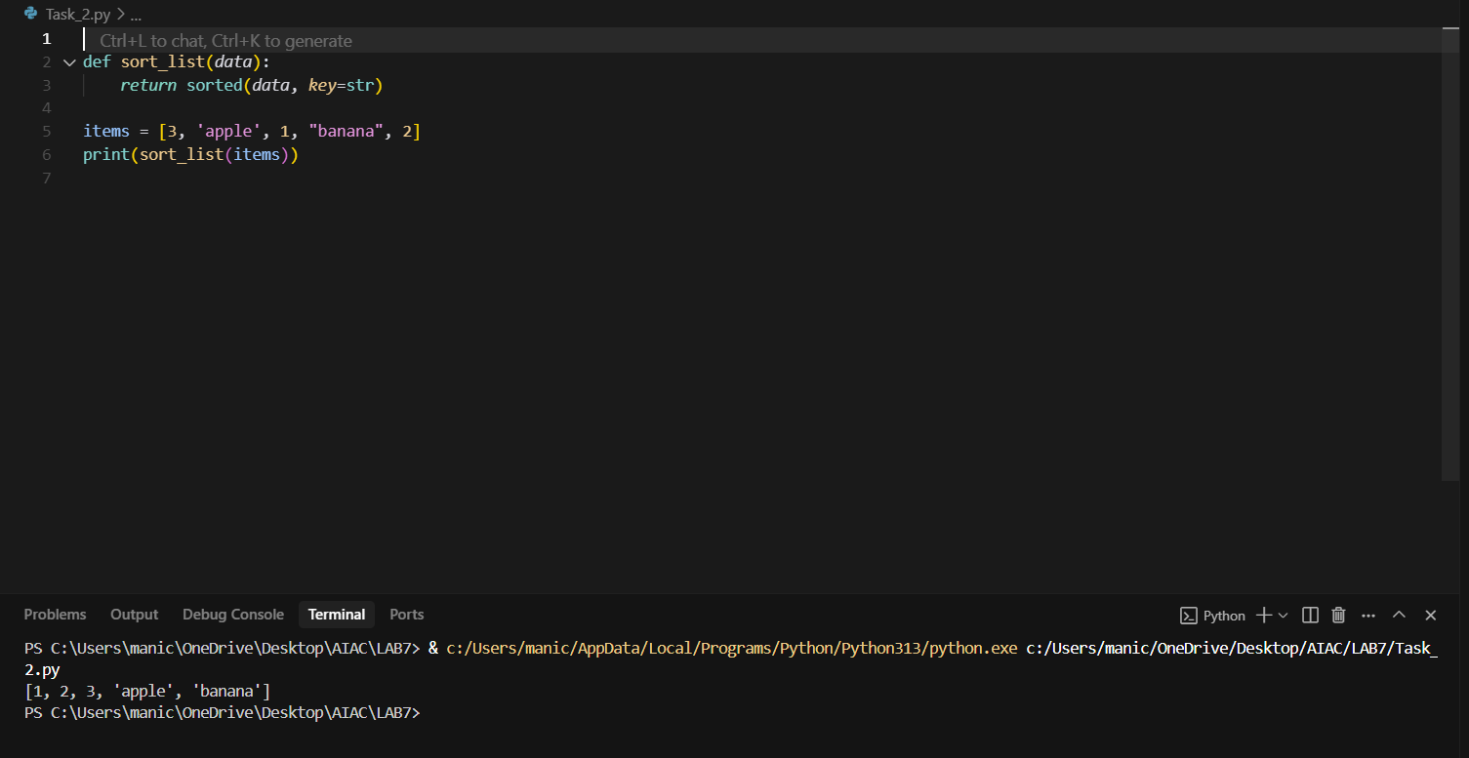
Task Description #3:
• Write a Python snippet for file handling that opens a file but forgets to close it. Ask Copilot or Cursor AI to improve it using the best practice (e.g., with open() block).
Code 1:
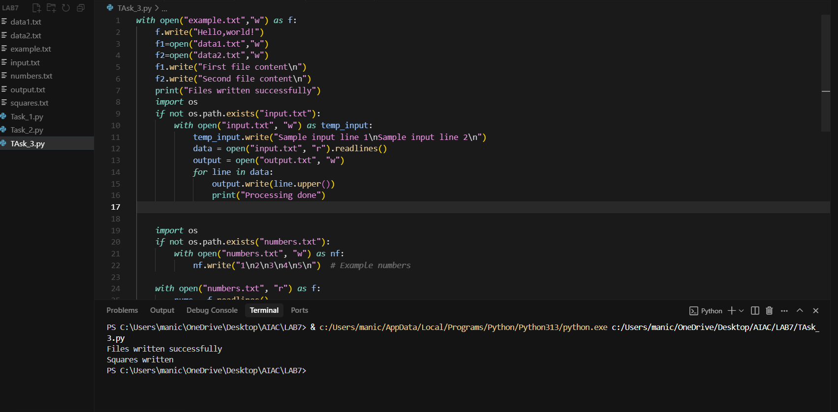

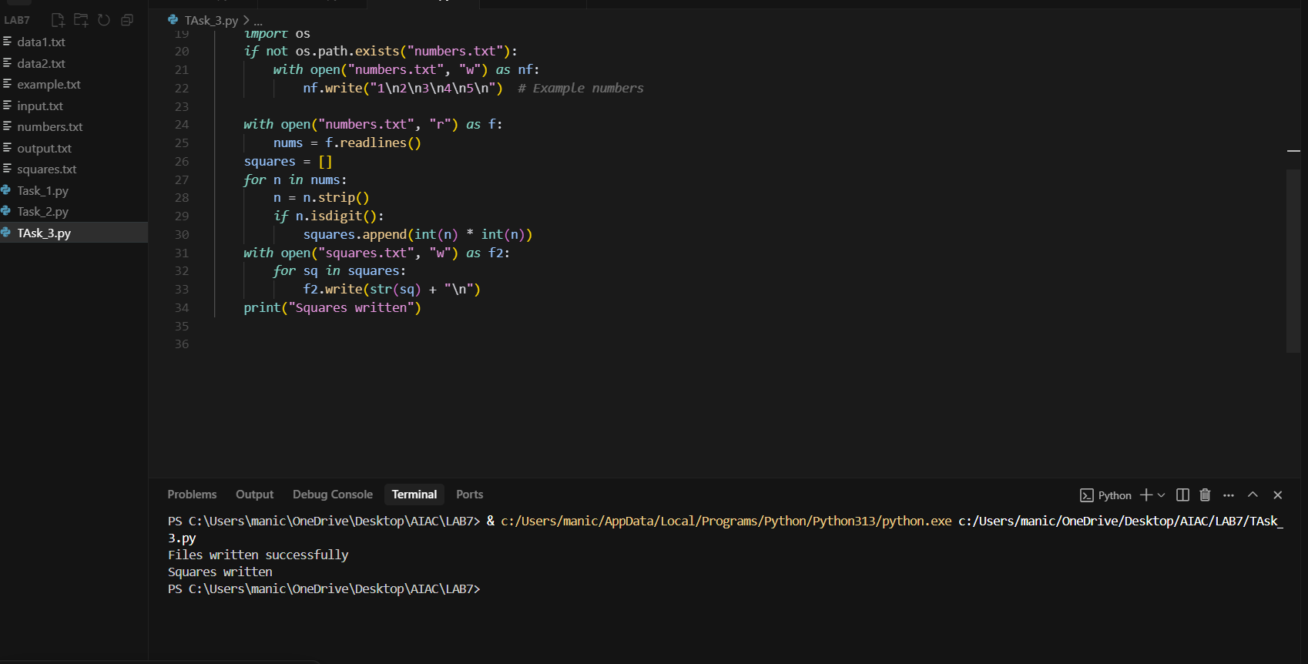

Task Description #4:
• Provide a piece of code with a ZeroDivisionError inside a loop. Ask AI to add error handling using try-except and continue execution safely.
Expected Outcome #4:
• Copilot adds a try-except block around the risky operation, preventing crashes and printing a meaningful error message.
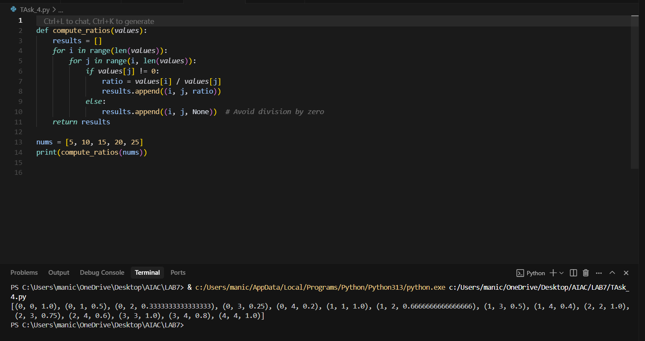

Task Description #5:
• Include a buggy class definition with incorrect __init__ parameters or attribute references. Ask AI to analyze and correct the constructor and attribute usage.
Expected Outcome #5:
• Copilot identifies mismatched parameters or missing self references and rewrites the class with accurate initialization and usage.
